Caregiver Lunch & Learn
Shared Decision Making for Family Caregivers and Patients
Making informed choices among different treatment options can be a challenge. The decision-making process ideally would take into account the best evidence available about the benefits and harms of any approach, as well as a patient’s individual characteristics, values, and preferences.
Jean Slutsky, PCORI
“Supporting Patients' Roles in Their Healthcare Decisions,” April 12, 2016
Caregiver Action Network (CAN) believes that family caregivers are one of the most important missing pieces in current efforts to maximize patient-centered outcomes, and that they should be made a primary focus of training efforts.
When patients and caregivers can clearly articulate their personal health goals, doctors can better point to treatment options that are clinically meaningful to individual patients and their caregivers, rather than “one-size-fits-all” standardized care treatment options.
But often caregivers and care recipients are ill-prepared to make informed decisions regarding their care when the time comes. When given the choice between multiple treatment options, or when new therapies become available, caregivers and patients frequently do not know how to select the best option for their situation.
To address this problem, CAN developed a Caregiver Lunch and Learn workshop to raise awareness of and increase the ability of family caregivers and patients together to use shared decision making and comparative effectiveness research in making important health decisions by teaching them:
Caregiver Lunch and Learn
- 4 hour workshop teaching SDM and CER
- Disease-specific real world examples
- Caregivers receive:
- Caregiver Kits
- $75 gift card
- Box Lunch
- How to clearly articulate their personal goals to their doctors to better ensure outcomes that are patient-centered.
- What comparative effectiveness research is and why it matters.
- How to combine family goals with comparative effectiveness research in shared decision making.

Seven workshops are being presented across the country with support from a Eugene Washington Engagement Award from the Patient Centered Outcomes Research Institute.

CAN is requesting your support for additional Caregiver Lunch and Learn workshops. Each workshop will reach 60 family caregivers in a community of your choice and can be targeted to a therapeutic area that you choose. On the following page, you will find details of the program and the results of on-going training sessions.
We hope you will consider funding Caregiver Lunch and Learn workshops and look forward to discussing this further.
For additional information, please contact
Mark Gibbons at 202-454-3969 or MGibbons@CaregiverAction.org.
Caregiver Lunch and Learn
Shared Decision Making for Family Caregivers and Patients

Opportunities for Future Workshops:
Current Workshop Locations Include:
Woodbridge, VA
Little Rock, AR
Ft. Wayne, IN
Albuquerque, NM
Los Angeles, CA
Houston, TX
Albany, NY
Each Caregiver Lunch and Learn workshop features one diagnosis, which is explored in depth. Caregivers role play and explore the various therapies and treatment options. Workshop locations can be customized to meet our mutual goals, such as the needs of a particular community, or disease prevalence. Future workshops can also focus on a disease that is germane to your goals. For example:

- Bone health
- Oncology
- COPD
- Sickle Cell
- Diabetes
- Caregiver health
- Atrial Fibrillation
- Mental health

There is an opportunity to fund additional Caregiver Lunch and Learn workshops. Your support will enable Caregiver Action Network to conduct a customized workshop to reach 60 family caregivers in a community of your choice.

Objectives:
- Provide family caregivers and patients with the knowledge and skills to become stronger team-based decision-makers.
- Teach patients and caregivers how to communicate their personal goals, values, and preferences to their doctors in order to arrive at treatment options that will be clinically meaningful to them as patients and caregivers and in line with their personal situation and health goals.
- Increase familiarity with, and expansion of the ability of patients and caregivers to use comparative effectiveness research to make important treatment decisions.
- Teach family caregivers, in particular, how to become more integrated in, and bring their valuable input to, the shared decision making process between their loved ones and their health professionals.
The Workshop:
There are four modules to the 4-hour workshop:
- Tools: How to use tools such as a Medication List and a Patient File, and how to prepare for doctor appointments and emergency room visits.
- Patient/Family Centered Goals: What patient and family centered goals are and how to determine them.
- Comparative Effective Research: What comparative effectiveness research is and why it matters. Includes an activity where participants role play a scenario of seeking out information on various interventions for their loved one’s diagnosis by presenting an example illness with two possible therapies, a clinical trial option, and no treatment at all as means to deal with the illness.
- Shared Decision Making: How to integrate patient and family goals with comparative effectiveness research and use this to advance shared decision making with the doctor and health care professionals (e.g., asking about alternative treatments and new therapies).

Results:
All participants complete pre- and post- workshop evaluation surveys. Post-survey results indicate that attendees have a better understanding of all four components after participating in the 4-hour training workshop. Responses demonstrate very positive results to the following questions on a scale of 1 (strongly disagree) to 10 (strongly agree):
What have caregivers learned in the workshop? They have said:

- I learned that options are a good thing to have -- even when making a hard decision

- I will listen more to the patient (my loved one)

- This was wonderful, but there are still things to learn….

- Be calm and be prepared!

- I know what “patient-centered goals” are.
  - Increase from 4.8 in the pre-survey to 8.3 in the post-survey.

- I understand why “comparative effective research” is important and why it matters to me.
  - Increase from 3.9 in the pre-survey to 7.8 in the post-survey.

- I know what “shared decision-making” is and why it is important.
  - Increase from 6.2 in the pre-survey to 8.8 in the post-survey.

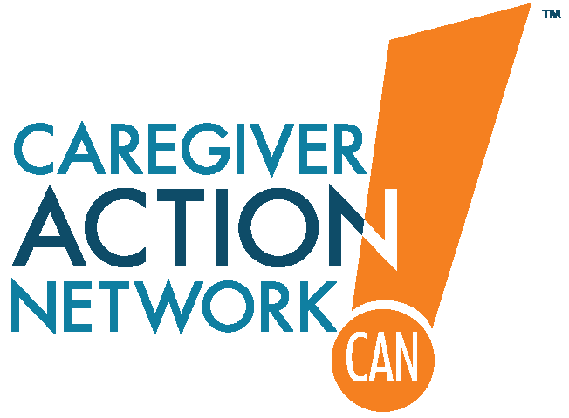
We hope you will consider funding Caregiver Lunch and Learn workshops and look forward to discussing this further.
For additional information, please contact
Mark Gibbons at 202-454-3969 or MGibbons@CaregiverAction.org.

Caregiver Action Network is the nation’s leading family caregiver organization working to improve the quality of life for the more than 90 million Americans who care for loved ones with chronic conditions, disabilities, disease, or the frailties of old age. CAN serves a broad spectrum of family caregivers ranging from the parents of children with special needs, to the families and friends of wounded soldiers; from a young couple dealing with a diagnosis of MS, to adult children caring for parents with Alzheimer’s disease. CAN (the National Family Caregivers Association) is a non-profit organization providing education, peer support, and resources to family caregivers across the country free of charge.

The National Family Caregivers Association DBA Caregiver Action Network
is a charitable organization under section U.S. 501(c)(3) of the IRS code. Tax ID 52-1780405.

