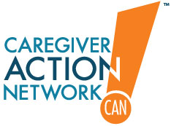 | Training Family Caregivers in Team-Based Medical Decisions  Medication List

Medication Record | As of: |  | Birth Date:
Patient Name:
Emergency Contact 1: |  |  | Phone:
Emergency Contact 2: |  |  | Phone:

Medications
Name of Drug | 1 | 2 | 3 | 4 | 5 | 6
Generic
Brand
OTC
How medication is administered (pill, capsule, injection, patch, ointment)
Dosage
What medication looks like
What the drug is treating
Side effects I’ve experienced
How and when to take medication
What not to do when taking medication
Name of prescriber
Name of pharmacy that filled prescription
Date Started
Date Stopped

Immunizations
Type | Date of Last Dose
Tetanus
Pneumonia
Flu
Hepatitis
Other

Reactions
Drug allergies and other significant reactions.
 | Drug | Reaction
 | 1
 | 2
 | 3
 | 4
 | 5
Recent medications that caused problems or didn’t work.
 | Drug | Problem
 | 1
 | 2
 | 3
 | 4
 | 5

Medical Team
PCP | Name:
 | Phone:
Specialist 1 | Name:
 | Phone:
Specialist 2 | Name:
 | Phone:
Pharmacy | Name:
 | Phone:

